Ready to Learn Kits
Cleveland Public Library
http://www.cpl.org
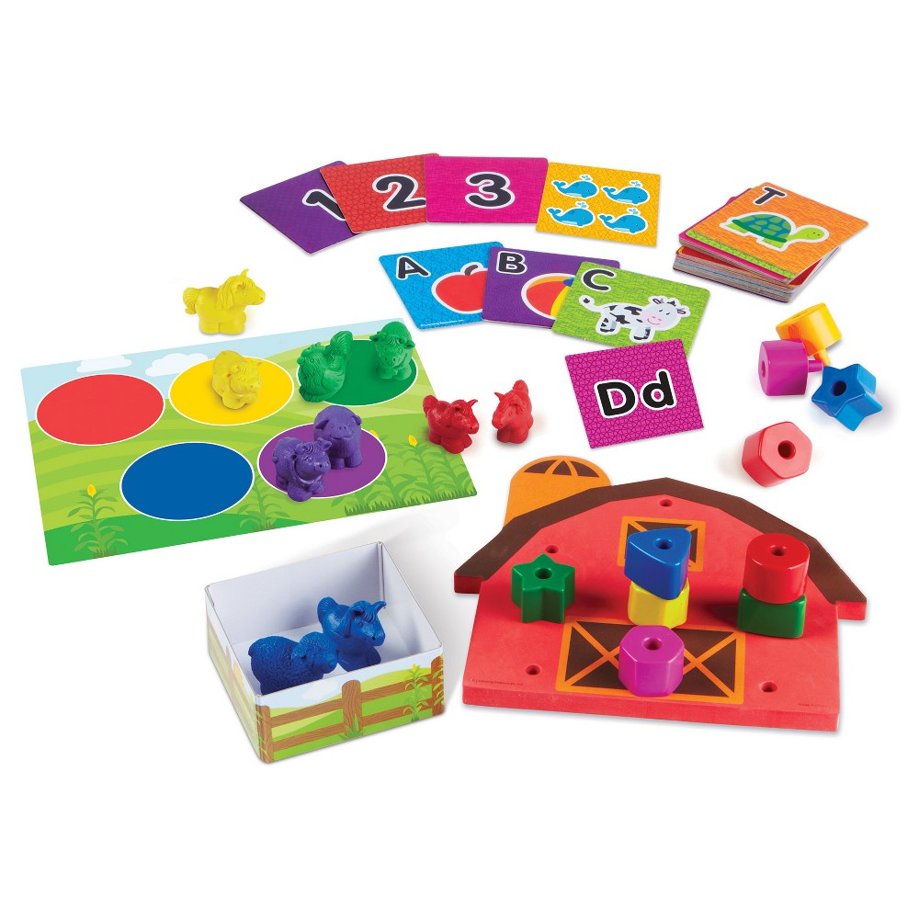

Ages 2-3

Order for pick up at a local library:
All ready for toddler time readiness kit

Contents: 26 alphabet cards -- 10 number and counting cards -- 10 farm animal counters -- 10 stacking pegs -- 1 activity mat --1 barn pegboard -- 1 corral -- parent guide.

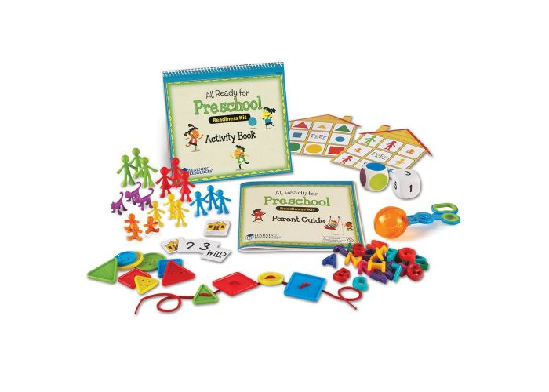
Ages 3-5

Order for pick up at a local library:
All ready for preschool readiness kit
Contents: 1 fine motor scooper -- 18 family counters -- 24 number cards -- 12 attribute buttons -- 26 uppercase letters --1 lace -- 1 number die -- 1 color die -- 2 double-sided game boards -- guide (36 pages) -- write & wipe activity book (22 pages) -- 1 dry erase marker.

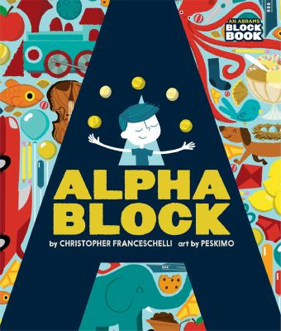
Kindergarten Ages 4-6

Order for pick up at a local library:
Kindergarten readiness backpack

Back pack Contents: Alphablock / Christopher Franceschelli ; illustrations by Peskim -- Llama llama yum yum yum! / Anna Dewdney -- I stink! / Kate McMullan, Jim McMullan -- Catch a letter magnetic learning game -- Wipe-clean workbook -- Dry erase marker.

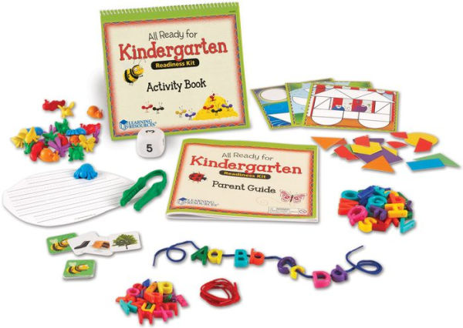
Order for pick up at a local library:
All Ready for Kindergarten kit

Contents: 1 gator grabber fine motor tool -- 20 critter counters -- 34 picture cards -- 20 puzzle cards with 60 shapes --1 number die -- 52 upper- and lowercase letters -- 1 lace -- 1 write & wipe board -- Parent guide (32 pages) -- Write & wipe activity book (24 pages) -- 1 dry erase marker.
01804
Ages 5-7

Order for pick up at a local library
Kindergarten Readiness Kit [Numbers]

Contents: Feast for 10 / Cathryn Falwell -- How many bugs in a box : a pop-up counting book / David A. Carter -- Numbers : touch think learn / Xavier Deneux -- Monkey balance : a fun counting and balance game -- Wipe-clean workbook -- Dry erase marker.
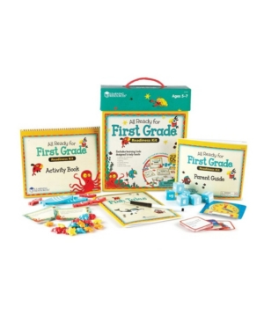
Order for pick up at a local library:
All Ready for First Grade

Contents: 20 ocean counters -- 10 double-sided word problem cards -- 6 word family cubes -- 1 write & wipe clock -- 20 double-sided story starter cards -- 1 writing journal (36 pages) - 6 measuring fish -- Parent guide (32 pages) -- Write & wipe activity book (24 pages) -- Dry erase marker.

Multiple Copy Sets - 10 copies available for class use or to order individually. Click on the title to order individually - call your local branch for multiple copy requests.

Peppa Pig Phonics
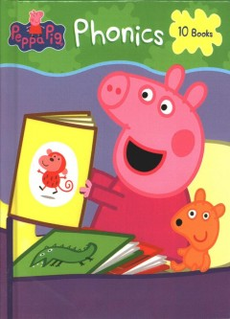
Book 1, short A. Look at that hat
Book 2, short E. The best pet
Book 3, short I. Fix-it Daddy Pig
Book 4, short O. Lots of jobs
Book 5, short U. Fun in the sun
Book 6, short A. Daddy Pig can!
Book 7, short E. They get wet
Book 8, short I. Peppa's trip
Book 9, short O. Mr. Fox's shop
Book 10, short U. Mummy Pig's good luck
Summary:
First-time readers can now follow along with Peppa while they learn their phonics sounds. Includes ten Peppa Pig stories written specifically to help children learn short vowel sounds -- adapted from publisher description

Alphabet

Children Learn to Relate Sounds With Letters
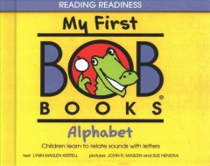
Contents:
1. AB
2. CD
3. EF
4. GH
5. IJ
6. KL
7. MN
8. OP
9. QR
10. STU
11. VW
12. XYZ.

Summary:
Pictures, words, and sentences that focus on the letters of the alphabet. Pre-reading skills.

Bob Books

Stage 2: Emerging Reader, Animal Stories

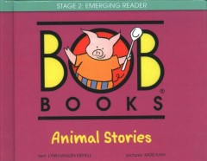
Contents:
1. Picky Pig
2. Mop
3. I will get you
4. The big tent
5. Pals
6. Stuck!
7. Silk dress
8. Ray and Jay
9. Hen's raft
10. Adrift
11. New nest
12. Two cats.
Summary:
In Bob Books First stories you will find twelve easy-to-read and humorous books. Perfect for emerging readers, this set including kid-approved stories that progress gently through graded reading levels A, B, and C. With one-syllable words and short vowels, Bob Books First stories is a fun confidence builder, especially for kids in Kindergarten

Bob Books
Set 3, Word Families
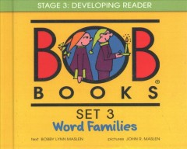
Contents:
1. Floppy Mop
2. Lolly-Pops
3. Frogs
4. The red car
5. Summer
6. Kittens
7. Funny bunny
8. Bed bugs
9. Activities for books 1-4
10. Activities for books 5-8.
Summary:
Consonant blends, endings, and a few sight words advance reading skills, gently building toward more complex stories. Use of word families makes longer stories more manageable for early readers.

